Alex Hoff

Programming Languages HW 2

Screen Shot of Game

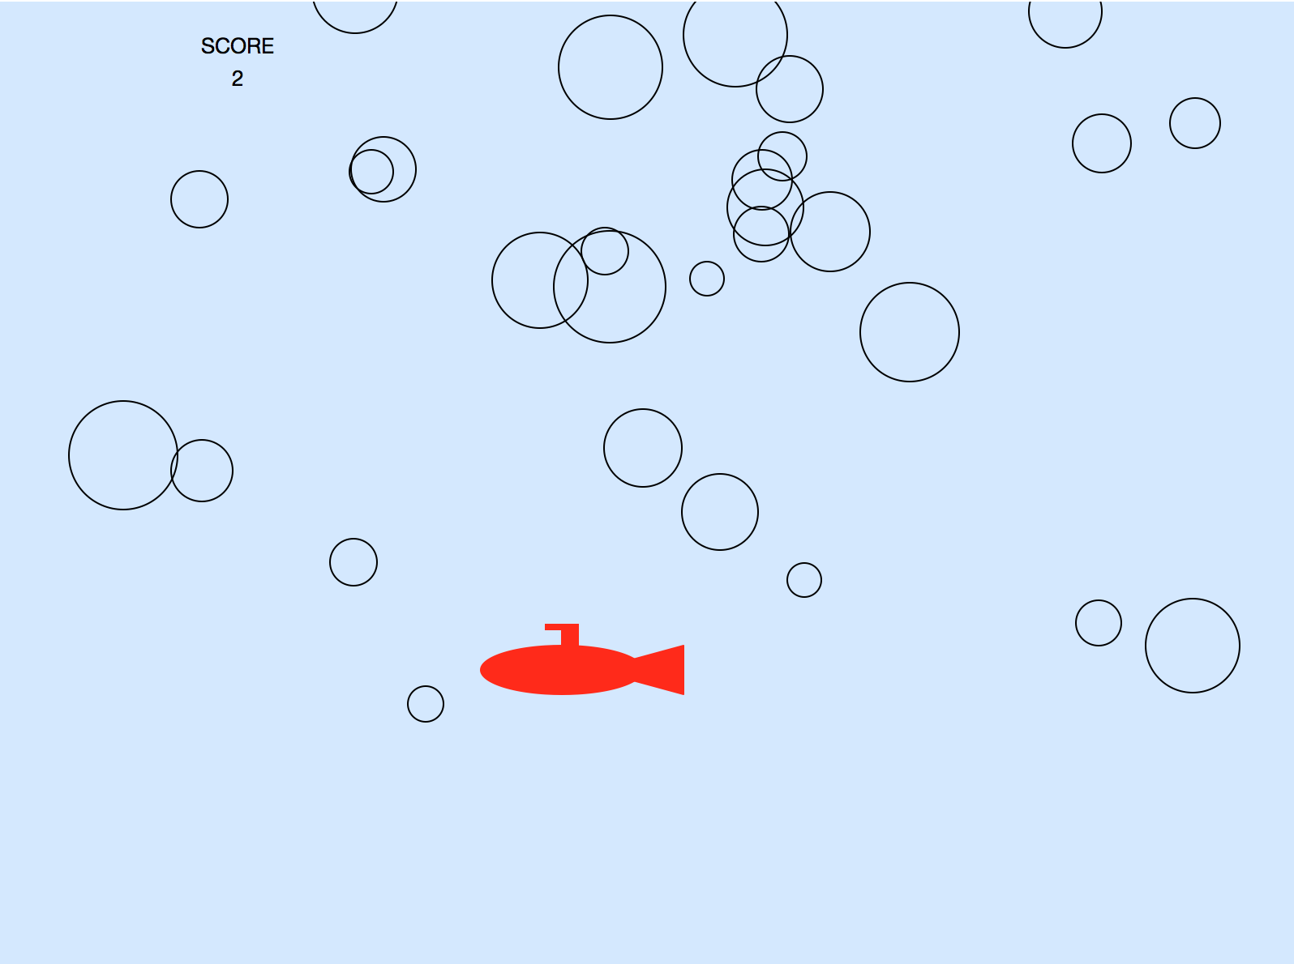

Questions

1. No Python is compiled so it is translated into machine code all at once using a compiler.
2. Yes because it runs as a list of commands instead of using objects
3. Yes
4. Globally
5. for x in range(x,y):
6. I found python very inflexible. Small errors broke the entire code.
7. I found python compiled and ran very quickly